PROUDLY PRESENT
‘RAROTONGA - BUSTED & BRUISED 2018’
FRIDAY 12 thru SUNDAY 21 OCTOBER 2018

Join us in October for the NZ BAY FISHER magazine fundraising sportfishing challenge in association with HEROWORX.

This year it’s ‘Raro Busted & Bruised – Round Two’ - a week of great fishing in the fabulous Cook Islands and all for a worthy cause. The local Puaikura Volunteer Fire Brigade is expanding its fleet and looking to fund operations for a new Fire Appliance. Please come along in October and let’s help raise some funds for this worthy volunteer organisation.

NEW TO 2018 This year the focus is on Team v/s Team. With a new format each team will be sponsored by a well-known brand to help identify and promote the competition between teams. Already we have confirmation from some big names so register now and be first to choose your teams sponsor.
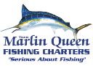
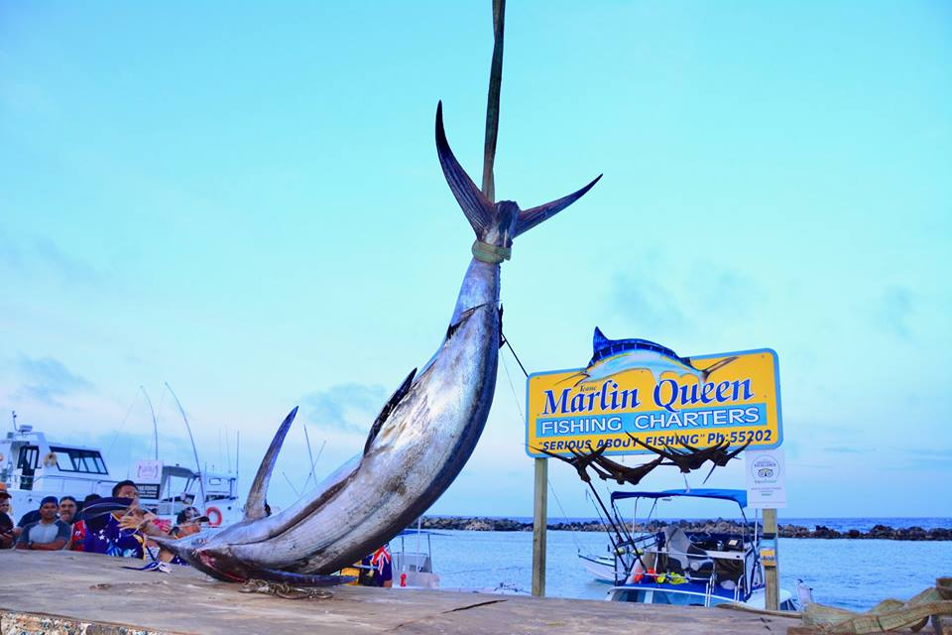
Unloading 310kg of blue marlin by crane. Busted & Bruised 2017
Cost $2,895.00 per person share twin. *
Non-fishing partners: $2195.00 per person share twin.
*Single room supplement $845.00
NB: These costs are currently only an estimate.
COST INCLUDES:
- Air travel Auckland/Rarotonga/Auckland flying Air New Zealand.
- Meet and Greet at Rarotonga International Airport plus return transfers to your resort.
- 9 nights’ accommodation on a share twin basis in a Garden Room at ‘Club Raro Resort’.
- Opening night Briefing & Drinks – Cook Islands Game Fishing Club.
- Four half day sport fishing trips. (approx. five hours fishing per trip)
- Prize Giving, Dinner, Drinks & Fundraising Auction
- Sponsored Team Apparel
COST EXCLUDES:
- Airport departure taxes unless included in air ticket cost.
- Travel Insurance – we recommend everyone takes out suitable cover for those unforeseen events.
- Food & Beverages unless stipulated in the itinerary.
- $30.00 Membership Fee to the Cook Islands Game Fishing Club.
ITINERARY
OCTOBER 2018
SAT 13 AUCKLAND/RAROTONGA – It’s an early check-in before departing 8.45am on Air New Zealand’s Boeing 787 Dreamliner Flight NZ61. During the flight our aircraft will cross the International Dateline arriving Rarotonga 1.35pm Friday afternoon.
FRI 12 RAROTONGA – On arrival, and having cleared customs and immigration, we’ll be greeted and transferred to our accommodation at Club Raro Resort or alternative hotel of choice.
OPENING NIGHT – “Meet the Skippers Briefing & Drinks”. A warm welcome this evening at the Cook Islands Game Fishing Club to meet the local Skippers and Deckies for drinks, tournament briefing and team boat draws. (See Fishing program)
SAT 13 FISHING – First day of fishing starts with the morning teams departing Avatiu Wharf 6.00 am and returning 11.00am. The afternoon teams depart Avatiu Wharf 12.00noon returning 5.00 pm.
SUN 14 FISHING – Day two and with points on the board from day one we should know who’s leading the charge and what’s required to climb the leader board.
MON 15 thru FRI 19 FISHING – Over the next five days each team will fish the remaining allocated half days with a couple of lay days scheduled for weather delays. Fishing times and boats will be posted well in advance with regular updates each evening from our headquarters at the Cook Islands Game Fishing Club.
SAT 20 PRIZEGIVING DINNER & FUNDRAISER AUCTION – Party time! Tonight, is awards time kicking off with pre-dinner drinks, an ‘Island Style Buffet’, Prizegiving and Grand Auction! (Full details to be finalised)
SUN 21 DEPART RAROTONGA – Late breakfast and time for final farewells before our transfer back to Rarotonga International Airport in time for a 2.55pm departure aboard our Air New Zealand Boeing 787 – Dreamliner Flight NZ45.
MON 22 ARRIVE AUCKLAND – (Labour Day) Having re-crossed the dateline during the flight our aircraft will arrive Auckland 6.20pm Monday evening.

THINGS YOU NEED TO KNOW…
ABOUT HEROWORX
- Heroworx.org is a ‘brothers in arms’ type project developed by Globalsportfish Limited, and its strategic partners in support of our offshore emergency responder communities. Volunteer groups who don’t always get the support some of our home-based volunteer emergency responder groups enjoy. Anyone and everyone is welcome to join us on this Heroworx project and become a supporter.
ACCOMMODATION:
- Our base is ‘Club Raro Resort’ in Tupapa, located just a short stroll from the Cook Islands Game Fishing Club, the town centre and the world-famous Trader Jacks Bar is a 15 -20 minute walk. It is also only a 5-minute drive (approx. 40-minute walk) to the charter boats docked in Avatiu harbour. The property offers a selection of rooms catering for everyone’s budget. (Room upgrades available – see Room Upgrade Supplements)
- Club Raro facilities include a swimming pool with bar, vending machines, small shop and restaurant.
- For those seeking a more upmarket accommodation, packages are available on request for the boutique Manuia Beach Hotel. Contact: peter@Globalsportfish.com for further details.
COOK ISLANDS GAME FISHING CLUB:
- The C.I.G.F.C. will be tournament headquarters. The club will be open each fishing day from 1pm for $3.50 beers and daily results.
DEPOSIT:
- A non-refundable $500.00 deposit per person will be required at the time of booking with the balance due 60 days prior to travel.

FISHING RAROTONGA:
- The fishing scene in Rarotonga starts before you leave the harbour with some of the biggest GT’s you will ever see cruising amongst the moored charter fleet. These beasts are mean and dangerous having sent many over exuberant fisho’s to the emergency department. While no one fishes for these big boys (they’re a local attraction; unofficially but fiercely protected by the Avatiu boys and girls) getting too close with the camera or dangling the wrong body part in the water can cause serious damage…

- The real fishing commences just a few minutes from the harbour entrance where the bottom drops away to 600 metres within a half a kilometre of the shore. The action can start at any time with Wahoo and Dog Tooth Tuna cruising just off the reefs and around one of the three strategically placed inshore F.A.D.’s. (Fish Aggregation Devices). Further offshore another five F.A.D.’s. can be located often holding schools of Yellow Fin Tuna, Mahi-Mahi and Marlin. With lines in the water just minutes after leaving port half day trips in Rarotonga offer plenty of fishing time with 5 hours on the water each trip.
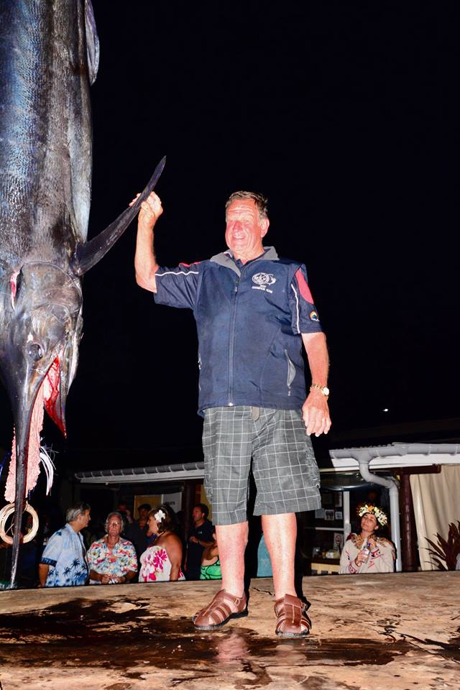
Rex Cotter with magnificent 249kg blue marlin after 5-hour fight.

Like most tropical destinations Rarotonga has a morning and afternoon bite. Fishing will be based around each team fishing 4 half day trips; two morning trips and two afternoon trips, providing everyone a chance to experience both bite times.
FISHING PROGRAM:
“Busted & Bruised” is a charity fishing event where the tournament is more about having fun and supporting a local volunteer emergency responder group rather than winning prizes. Predominantly a team challenge, the competition will be based around the team’s total fish weight at the end of 4 days fishing. There will be individual awards for the heaviest fish in each section. Full details and a list of prizes will be released at the ‘Opening Night Briefing’.
FISHING TEAMS
- The tournament is limited to just eight international teams.
- Local fishing teams are welcome to enter the tournament fishing the same times on the water as the visiting teams.
- Teams are made up of four members with each team fishing a different charter vessel each day.
- Charter vessels will provide all tackle required for trolling lures, baits etc. Teams wishing to jig and use poppers around the F.A.D.’s will need to bring their own equipment. (Some very nasty toothy critters so be prepared…)
SINGLE ANGLERS:
- Every effort will be made to accommodate single anglers wishing to join a team. If you are a single angler and wish to participate, please contact peter@globalsportfish.com and he will do his best to get you a place with a team looking for an angler.
FUND RAISING AUCTION:
- Following drinks and dinner on Prize Giving evening there will be a ‘Grand Auction’ in support of the local Puaikura Volunteer Fire Brigade. A selection of donated items including marine electronics, fishing tackle and travel related product will be auctioned with all the proceeds going to this very worthy cause.

RENTAL CARS:
- Rental cars and motor bikes can be booked prior to arrival or once on the island. Please contact: peter@globalsportfish.com for assistance or advice.
ROOM UPGRADE SUPPLEMENTS:
Accommodation has been based on standard garden rooms. If you wish to upgrade to a different room type the following supplements will apply:
- Poolside Room: TBA
- Beachside Room: TBA
POST TOURNAMENT TRAVEL OPTIONS:
- For those wishing to extend their Heroworx Busted& Bruised sport fishing escape the Mondo crew highly recommend a visit to the island of Aitutaki. This tropical paradise is just a 50-minute flight from Rarotonga and features one of the most stunning lagoons found anywhere in the world.
AITUTAKI 3 nights/4days $1170.00 per person share twin (estimate only)
Cost Includes
- Return flights flying Air Rarotonga.
- Meet & Greet Aitutaki Airport.
- Return Hotel Transfers.
- Daily Tropical Island Breakfast.
- 3 nights’ accommodation Tamanu Beach Resort.

CONTACT/REGISTER:
To obtain further details or register your fishing team for ‘Raro Busted & Bruised 2018’ contact Peter Barry on email: peter@globalsportfish.com or call on 021 434 220.

REGISTRATION FORM:
(Each person travelling must complete this form and return to GLOBALSPORTFISH PO Box 204 PAIHIA 0247)
FULL NAME: (as per passport)
…………………………………………………………………………………………………………….
ADDRESS: ……………………………………………………………………………………………………….
………………………………………………………………………………………………………………………..
………………………………………………………………………………………………………………………..
………………………………………………………………………………………………………………………..
EMAIL: ……………………………………………………………………………………………………………
PHONE: ………………………………………………………………………………………………………….
PASSPORT NO: ……………………………………………………………………………………………….
NATIONALITY OF PASSPORT: ………………………………………………………………………….
PASSPORT ISSUE DATE: ………………………………………………………………………………….
PASSPORT EXPIRY DATE: ………………………………………………………………………………..
DATE OF BIRTH: ……………………………………………………………………………………………..
SHIRT SIZE: ……………………………………………………………………………………………………..

BANKING DETAILS
PAYMENTS: All payments are to be made to Sporting Tours Ltd, Bank Account No. BNZ 02 02389 0003199 004. Sporting Tours Ltd is a division of Mondo Travel Mt Eden, a fully Bonded TAANZ and IATA accredited travel agency.

